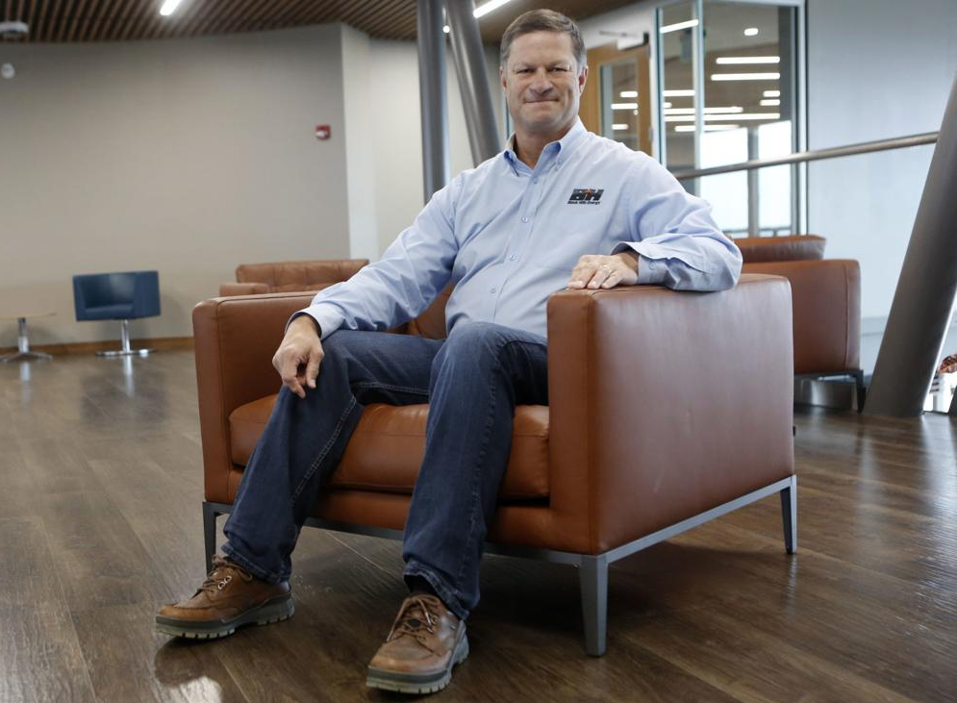

David R. Emery, age 57, is Executive Chairman of Black Hills Corporation (NYSE: BKH), a customer-focused, growth-oriented utility company headquartered in Rapid City, South Dakota. The company serves 1.27 million electric and natural gas utility customers in more than 800 communities in eight states.
Emery served as Chief Executive Officer from 2004 - 2018 and Chairman of the Board from 2005 - 2018. He also served as President from 2004 through 2015. Prior to being named CEO he held several other roles with the company, including President and Chief Operating Officer – Retail Business Segment from 2003 to 2004, and Vice President – Fuel Resources from 1997 to 2003. From 1993 to 1997, Emery was General Manager of the company’s oil and gas subsidiary. Between 1989 and 1993 he served in the oil and gas subsidiary as an Engineering Manager and Petroleum Engineer. Emery has been employed by Black Hills for 30 years.
Prior to joining Black Hills Corporation, Emery worked as a Petroleum Engineer for Union Pacific Resources in Denver, Colorado; Rock Springs, Wyoming; Houston and Fort Worth, Texas.
He holds a B.S. degree in Petroleum Engineering from the University of Wyoming, a M.B.A. from the University of South Dakota and is a Registered Professional Engineer.
Emery was selected as a Distinguished Alumnus by the University of Wyoming, Alumnus of the Year by the University of South Dakota College of Business, and is a Distinguished Eagle Scout.
Emery is an enrolled member of the Cheyenne River Sioux Tribe. He is a member of the Board of Directors for the Federal Reserve Bank of Minneapolis. He previously served on the Board of Directors for the United States Chamber of Commerce, the Edison Electric Institute and the American Gas Association. He is active in state and community affairs, currently serving on three gubernatorial-appointed boards in South Dakota and one in Wyoming. He is also involved in various charitable and non-profit community organizations.

